Student’s Name
Institutional Affiliation
Tutor
Date

IV Hydration project plan
This project involves converting the office waiting room into a IV hydration rooms because of demand. The doctor has a large number of clients who visit the hospital seeking IV Hydration services; thus, conversion of the room is urgent to cover this group of clients. The projected budget for the project is $1000 and its completion should be done within 3 months. This project plan gives a detailed project milestones and goals, presents the work breakdown structure, project activity scheduling , the stakeholder responsibility matrix and the overall project budget.
Milestones and Goals
The main objective of this project is converting the hospital waiting room into IV Hydration room. The whole conversion process is projected to be completed in 3 months at a cost of $1000. The milestones illustrated in the first section of the project represent the main periodical achievements of the project. Also, the periodical accomplishments of the project are illustrated in the milestones as they represent major project tasks. The presentation of the milestones is done in a simple way in which all stakeholders in the project are able to read, interpret and understand.
The Work Breakdown Structure
This project management tool represents a hierarchical arrangement of project deliverables basing on the overall scope of the project. This tool will help in the subdivision and classification of IV Hydration Room project deliverables into smaller manageable work (Radujković,& Sjekavica, 2017). This is particularly important as it helps in the identification of the necessary work to be completed in the project and clearly illustrate how the various activity packages are to be done. This is achieved by defining various activity levels to monitor project costs and estimate the processes in the project. Additionally, work breakdown structure is vital in ensuring effective communication within the project which is crucial in faster issue resolution and ensuring the overall success in the project. The WBS of IV Hydration Room project is given in Appendix A.
Project phases
Room renovation just like room renovation involves few process phases. Application of various project management tools are used in the project to specify the project and define the main objective of deliverables which will ensure quality. Subdivision of the tasks helps the project manager to take control of the project thus ensuring efficiency. The tools such WBS and Gantt Chart in serving as a guideline on improving the management processes. Activity definition and sub phasing them helps in controlling resources allocated, assigning responsibility to various personnel within the project and improve the overall definition of the project on periodical basis (Radujković, & Sjekavica,2017).
This room conversion process is process-based, this is because most of the tasks that are involved in the project are intangible and the realization of the desired outcome is majorly based on a series of processes. The major phases of this project are;
1) Project initiation phase
2) Room partitioning and framing
3) Interior designing
4) Finishing.
Activity Prioritization
In order to meet the expectations and ensuring project quality, there is need to ensure that trade-offs within the project are efficiently managed, cost and performance are also efficiently managed (Radujković, & Sjekavica, 2017). This room conversion project, the overall arrangement and plan in the room is constrained to the needs of the clients. Similarly, the amount of time allocated, the place of work and the size of the room being converted are also an acceptable criteria in the project. acquisition of the necessary room equipment such as the mini fridge, chairs, and TV are among the enhanced criteria.
Project Resource Allocation
Due to the small nature of the project, resources should be optimally allocated so as to attain the overall requirements and the quality of the project. Finances, human resource and equipment must be effectively allocated so as to avoid depriving others tasks off the required resources as well as minimizing conflicts in the project. resource allocation in the IV Hydration Room project as indicated below. 2 project team personnel are given specific responsibilities of partitioning and converting the room. The appointed project manager is responsible in assigning the team members to various tasks as well as conducting supervisory activities.
Jane: Project manager, responsible in liaising with the project stakeholders and in obtaining the required permits and is responsible in managing the project budget
Jacob: partitioning of the room ad framing, installation of electric cables, painting and installing the drywalls
Mat: in charge of the procurement process, acquisition of TV, mini fridge and chairs
The responsibility matrix
This is a summary of activities that needs to be completed and the person in charge of various tasks in the project. Below is a table that represents the responsibility matrix that is assumed in the IV Hydration Room conversion and the project personnel that is responsible for the activities. In the table; (i) represents the person in charge of the task and the (m) person responsible in supervising the task.
Activity | Jane | Jacob | Mat
Permit | (i)
Preparation of the room |  | (i)
Partitioning and framing | (m) | (i)
Electrical wiring | (m) | (i)
Purchases |  | (m) | (i)

Conclusion
Optimal project management is vital to the realization of success in the project. It gives the project manager with the required resources and equipment that will ensure the project success. achieving optimal management in the project relies on the effective planning processes and the overall skill set of the project manager. Also, the overall planning process in the project leads to its success, resource allocation, classification of the project deliverables using WBS, development of the responsibility matrix, setting the scope of the project, its deliverables and milestones play a role in achieving the required quality in the project. These tools play a major role in ensuring realization of the project objectives, proper management in the project and efficient allocation of finances in the project finances. Adoption of these project management tools and tables are vital in ensuring its success.

Appendix A
WBS
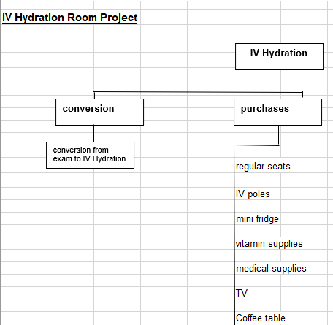

Appendix B
Project schedule Gantt Chart
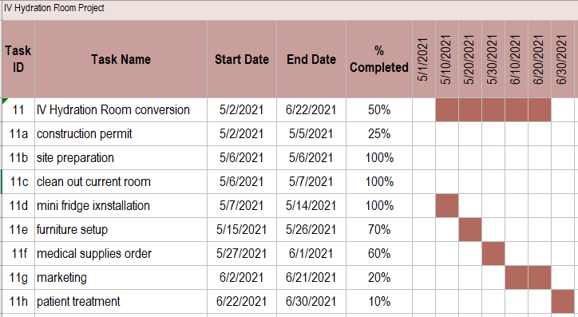

Appendix C
Project Budget
Item | No. | Allocated cost | Total
Firm
Project leader salary | 1 | $300 for the whole project | $300
Workers | 2 | $500 for the whole project | $500
Supplies
Timbers and boards | 50 units | $40 each | $200
Total $1000

Appendix D
Activity on Network

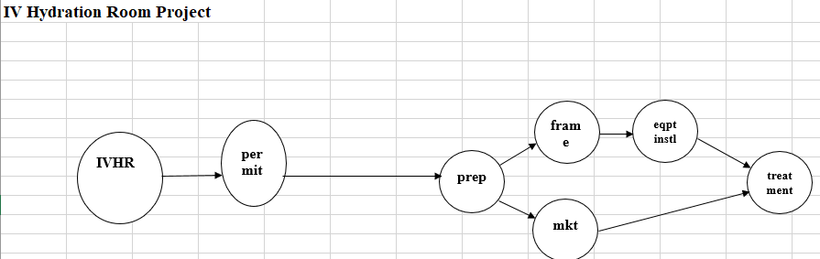

References
Radujković, M., & Sjekavica, M. (2017). Project management success factors. Procedia engineering, 196, 607-615.

